|  |  |
| --- | --- |
| **Experiment Number** | **05** |
| **Date of Experiment** | 18/09/2023 |
| **Date of Submission** | 09/10/2023 |
| **Name of the student** | **MANODEEP RAY** |
| **Roll Number** | **2230028** |
| **Section** | ECS-01 |

**Aim of The Experiment :-**

Familiarization with basic image processing techniques using LabVIEW.

**Equipment and Software Required:-**

The Equipment and Software required are as follows:

LabVIEW

**Block diagram:**

**Displaying image(in grayscale) on the front panel by inputting via path (2230028)**

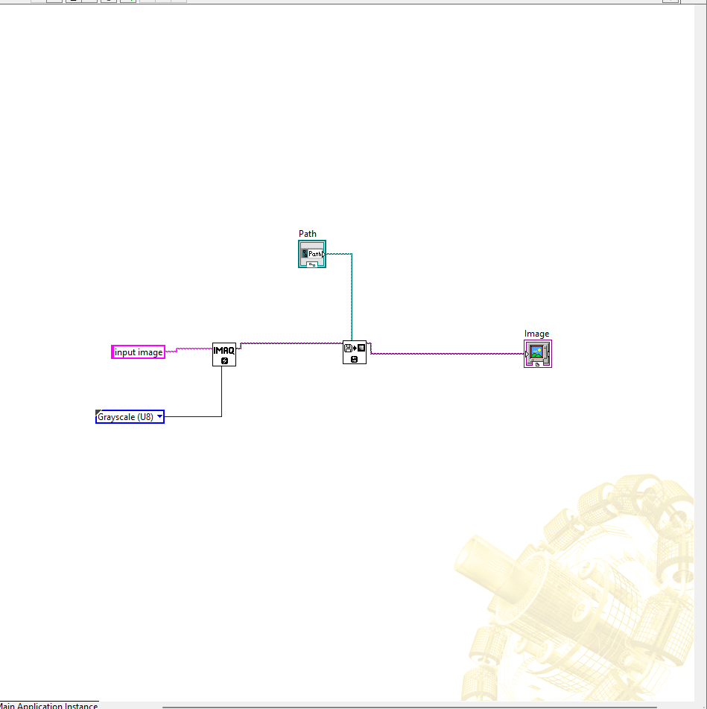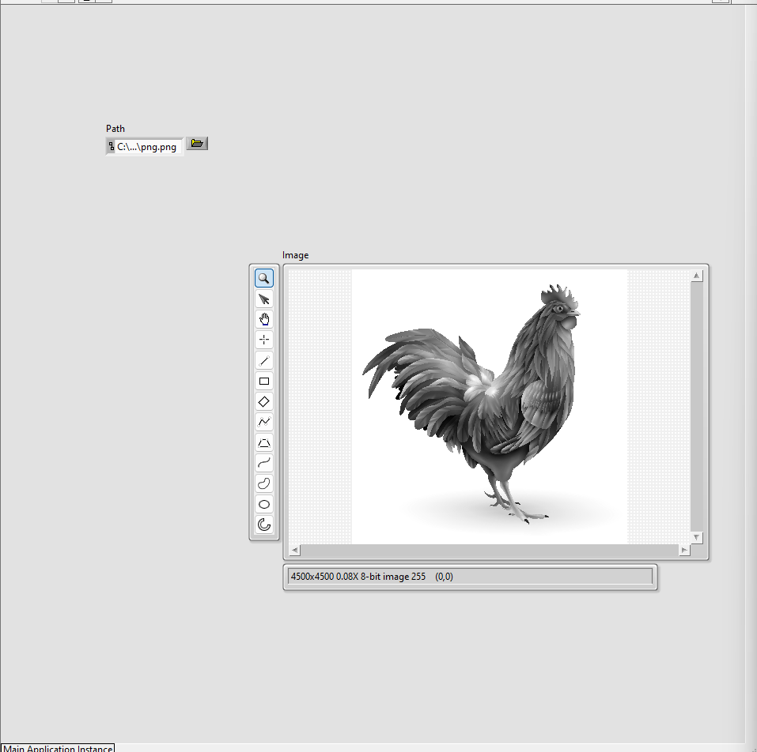

**Basic Operations of the Input Image and Displaying on the Front Panel (2230028)**

1. Basic displaying of image (in grayscale).
2. Color inversion of image.
3. Horizontal Flipping of image.

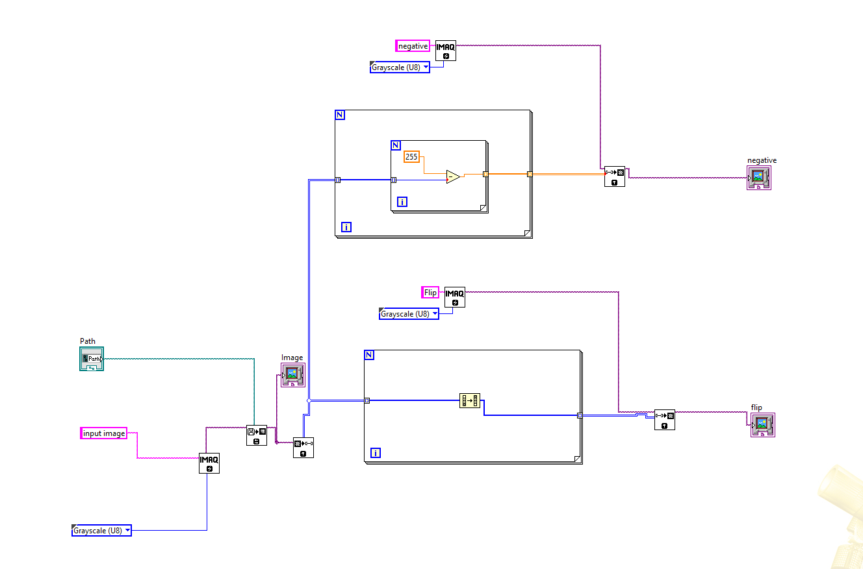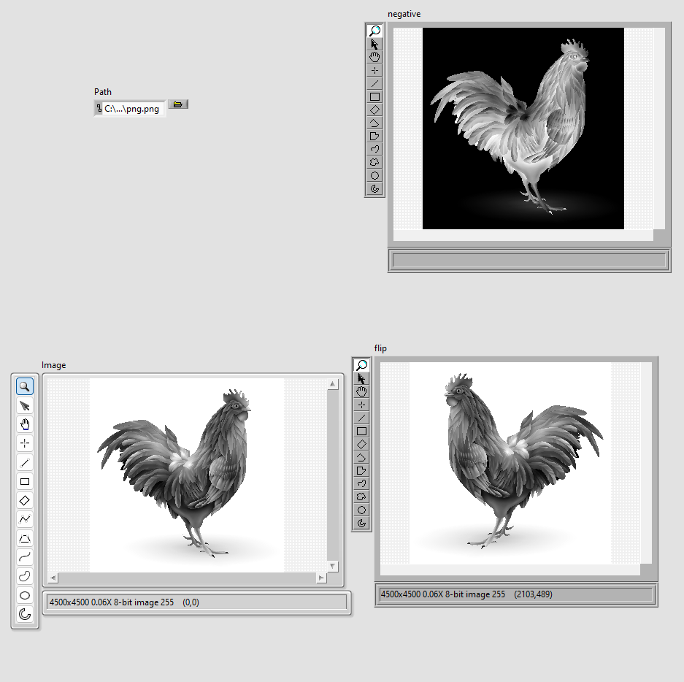

**Discussion or Inference of the experiment:**

From this experiment we made a circuit for doing basic operations on images (like input via path,

, displaying ,using array to store the info of all the pixels of the image use IMAQ in labVIEW) , we converted image to grayscale and displayed it on the front panel ,we inverted the colours of the image by inverting the colour of each pixel(subtracting by 255), flipped the image horizontally (by reversing the array(1-D) of pixels) - using LabVIEW.(we used FOR loops for all the array operations)

**Conslusion:**

This experiment taught us how to create VI’s using LabVIEW, how to use IMAQ operations ,use arrays for images, wiring , generate image outputs , input image ,do operations on arrays(the elements of the arrays), use for loops ,etc .